**TITLE OF LAB: (FOURIER SERIES REPRESENTATION OF CONTINUOUS TIME SIGNAL)**

**LAB # 10**



**Spring 2022**

**CSE301L Signals & Systems Lab**

Submitted by: **Safi Ullah Khan**

Registration No.: **20PWCSE1943**

Class Section: **B**

“On my honor, as student of University of Engineering and Technology, I have neither given nor received unauthorized assistance on this academic work.”

Student Signature: ______________

Submitted to:

**Engr. Durr-e-Nayab**

Day, Date (e.g Monday, June 20th, 2022)

**Department of Computer Systems Engineering**

**University of Engineering and Technology, Peshawar**

**OBJECTIVES OF THE LAB**

**‐‐‐‐‐‐‐‐‐‐‐‐‐‐‐‐‐‐‐‐‐‐‐‐‐‐‐‐‐‐‐‐‐‐‐‐‐‐‐‐‐‐‐‐‐‐‐‐‐‐‐‐‐‐‐‐‐‐‐‐‐‐‐‐‐‐‐‐‐‐‐‐‐‐‐‐**

This lab aims at the understanding of:

* Fourier Series Representation of Continuous Time Period Signals
* Convergence of Continuous Time Fourier Series

**‐‐‐‐‐‐‐‐‐‐‐‐‐‐‐‐‐‐‐‐‐‐‐‐‐‐‐‐‐‐‐‐‐‐‐‐‐‐‐‐‐‐‐‐‐‐‐‐‐‐‐‐‐‐‐‐‐‐‐‐‐‐‐‐‐‐‐‐‐‐‐‐‐‐‐‐-**

**-------------------------TASK 01--------------------------**

* In above example, ak’s are chosen to be symmetric about the index k=0, i.e., ak = a‐k. Select new ak’s on your own to alter this symmetry and form the new signal. What do you observe? Is x(t) a real signal when coefficients are not symmetric?

**Screenshot of Input:**

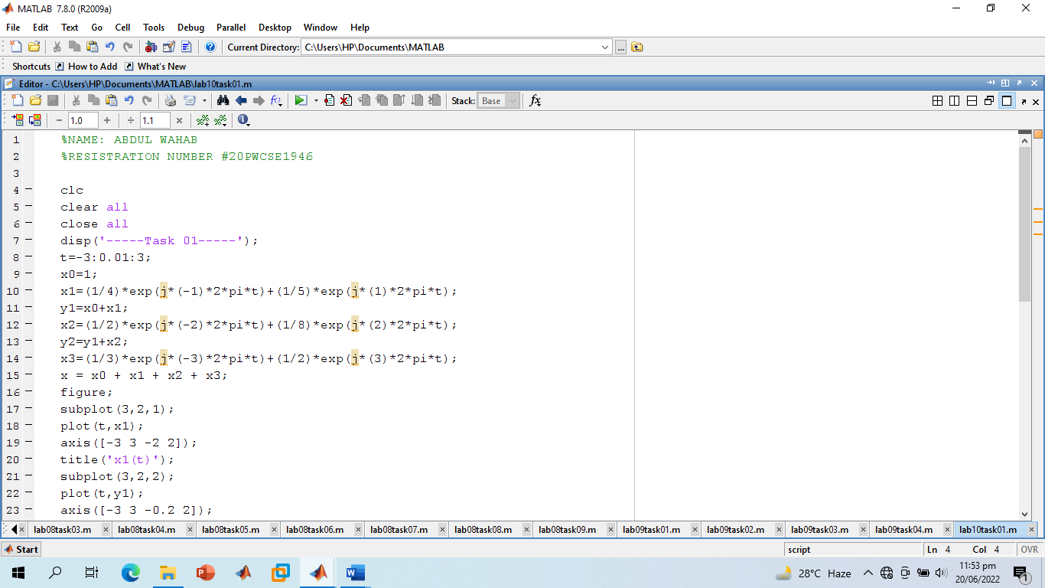

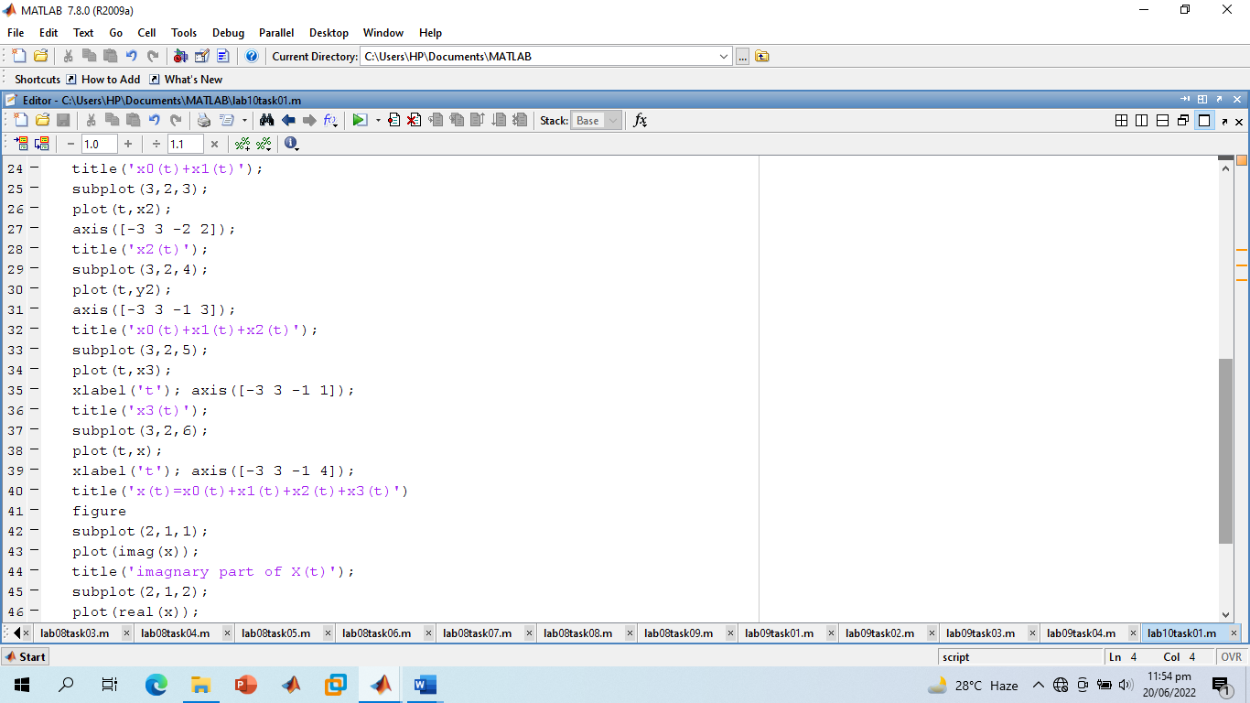

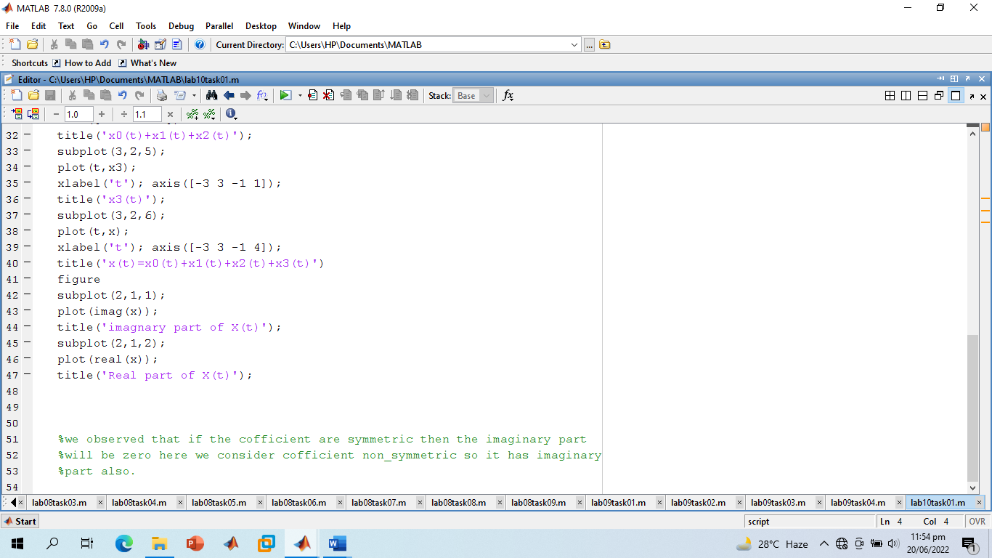

**Screenshot of Output:**

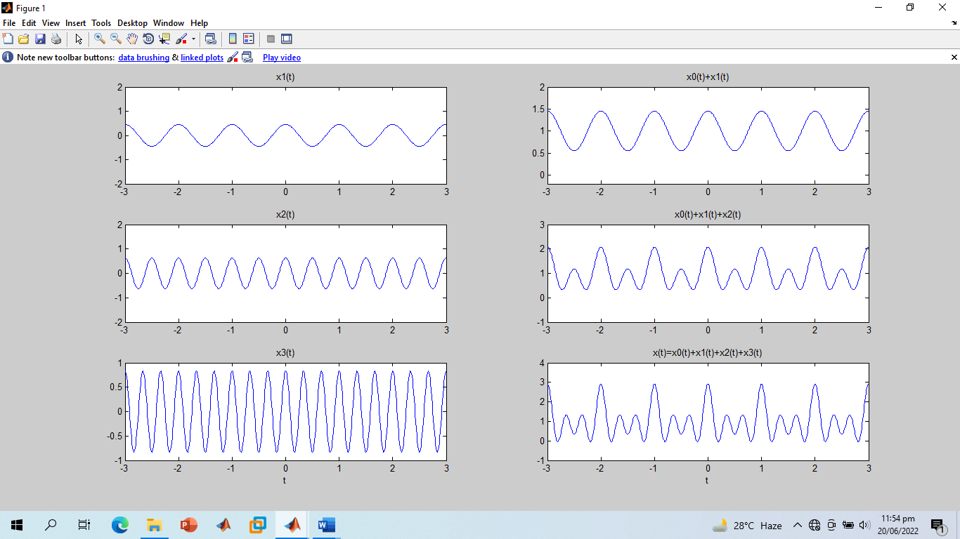

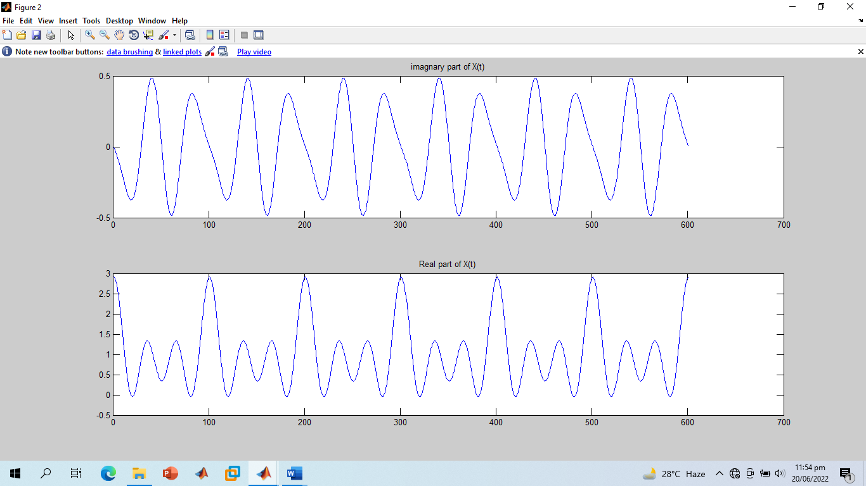

**-------------------------TASK 02--------------------------**

* A discrete‐time periodic signal x[n] is real valued and has a fundamental period of N = 5. The

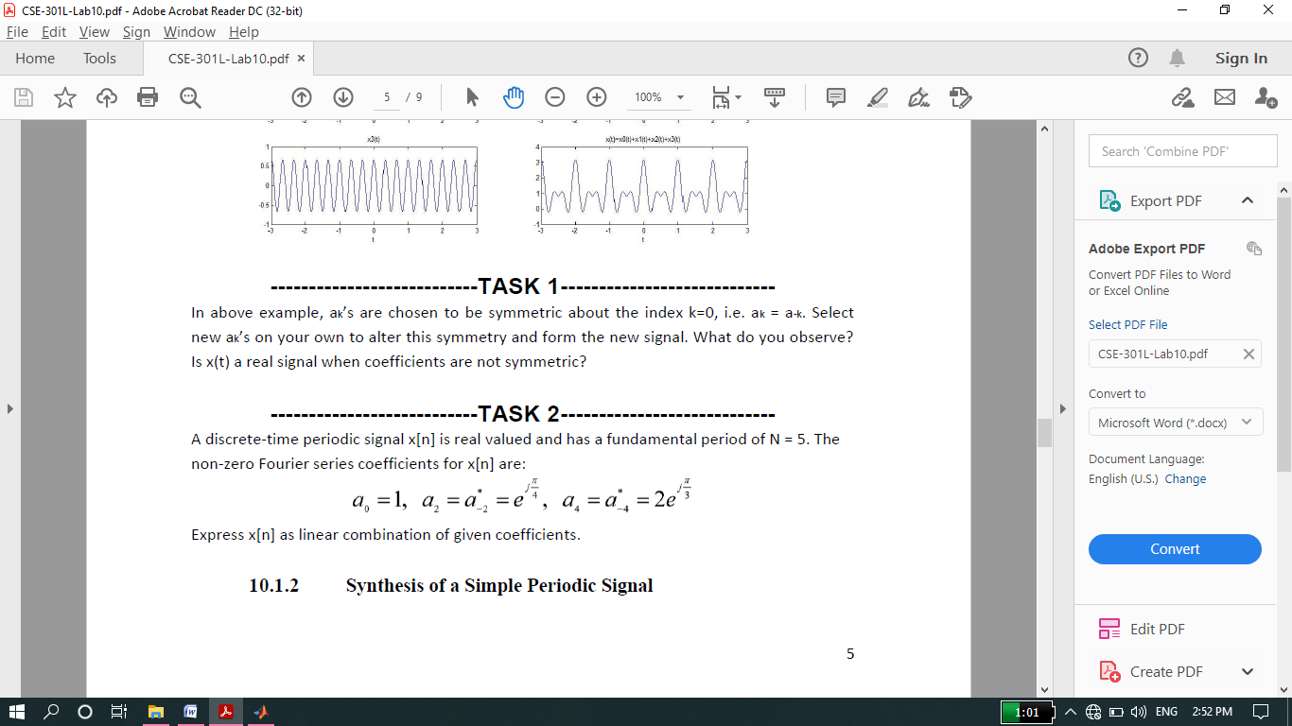

Non‐zero Fourier series coefficients for x[n] are:

* Express x[n] as linear combination of given coefficients.

**Screenshot of Input:**

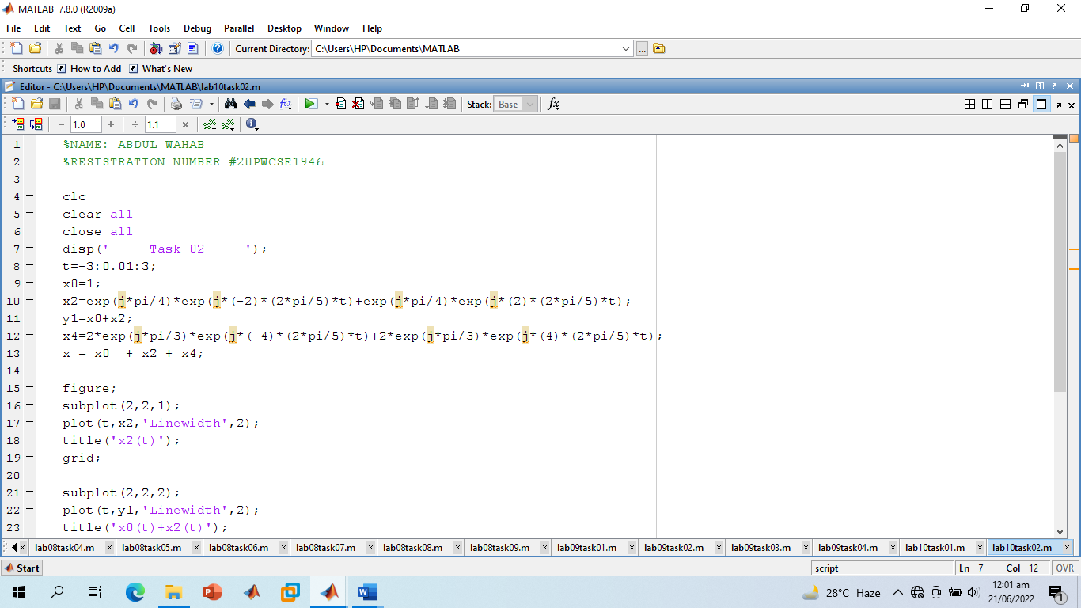

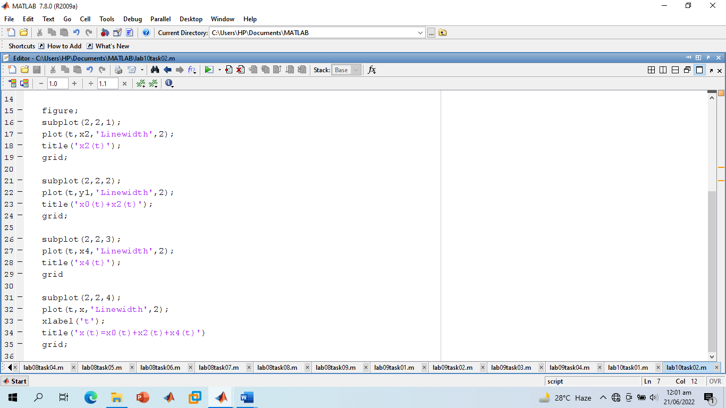

**Screenshot of Output:**

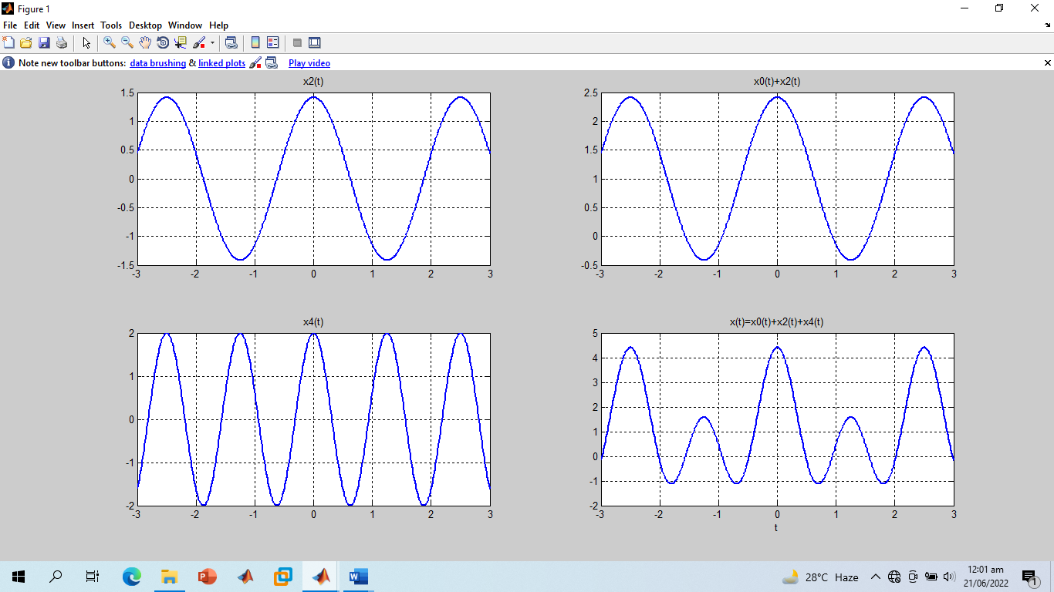

**-------------------------TASK 03--------------------------**

* Considering the FS coefficients plot given below, what do you observe happens to the envelope of the coefficients when T1 is reduced from 1/4 to 1/16 with constant time period T?

**Observation:**

* As T1 is changed from ¼ to 1/16 and we observed that the frequency of wave decreases and time period increase.

**Screenshot of Input:**

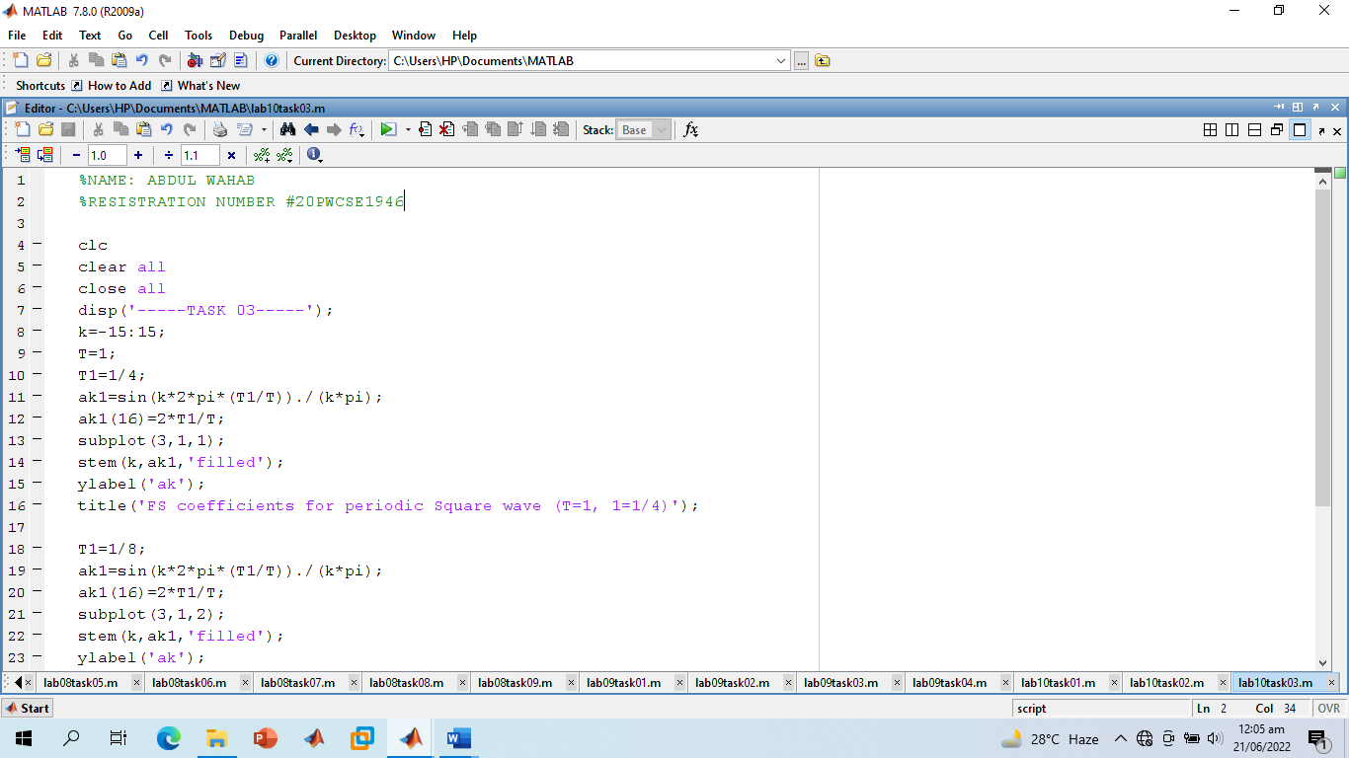

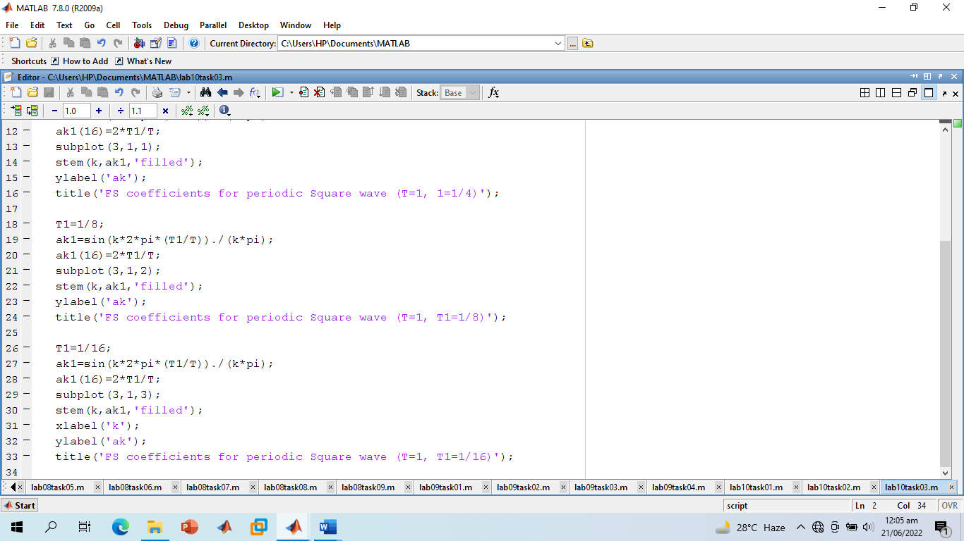

**Screenshot of Output:**

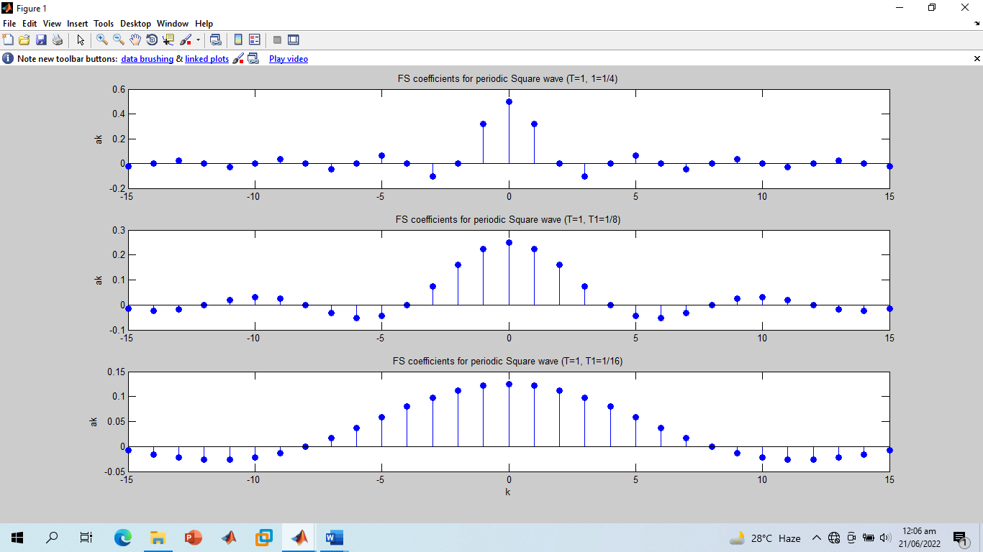

**-------------------------TASK 04--------------------------**

* Create the plots of square wave reconstructed using M = 10, 20, & 100 terms above, what do you observe about Gibb’s phenomena?

**Screenshot of Input:**

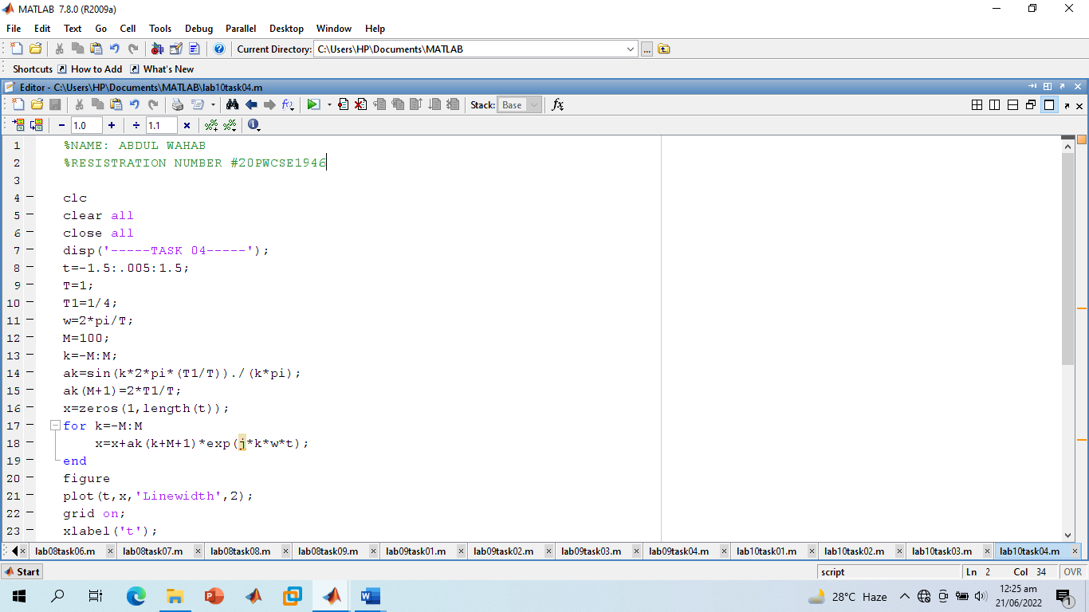

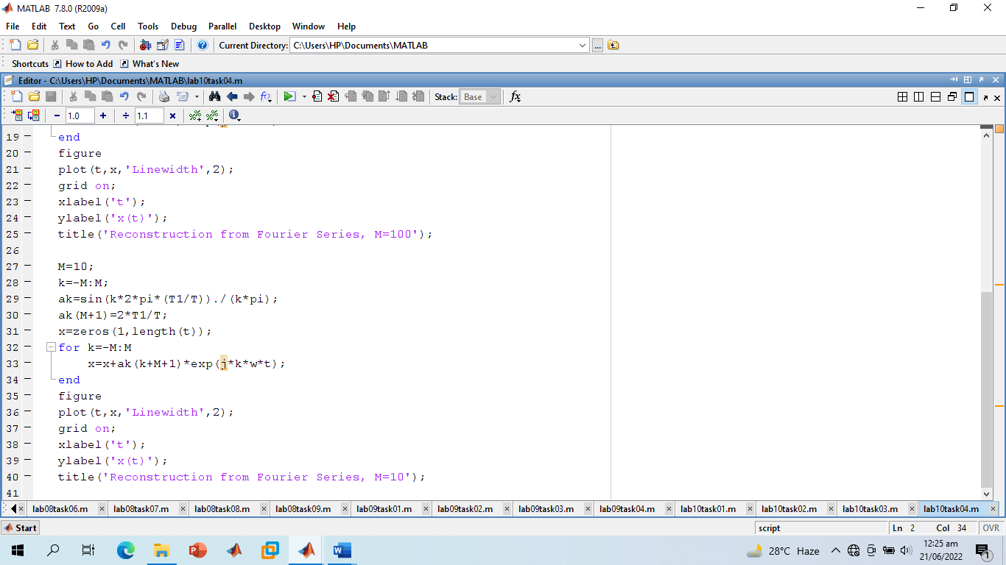

**Screenshot of Output:**

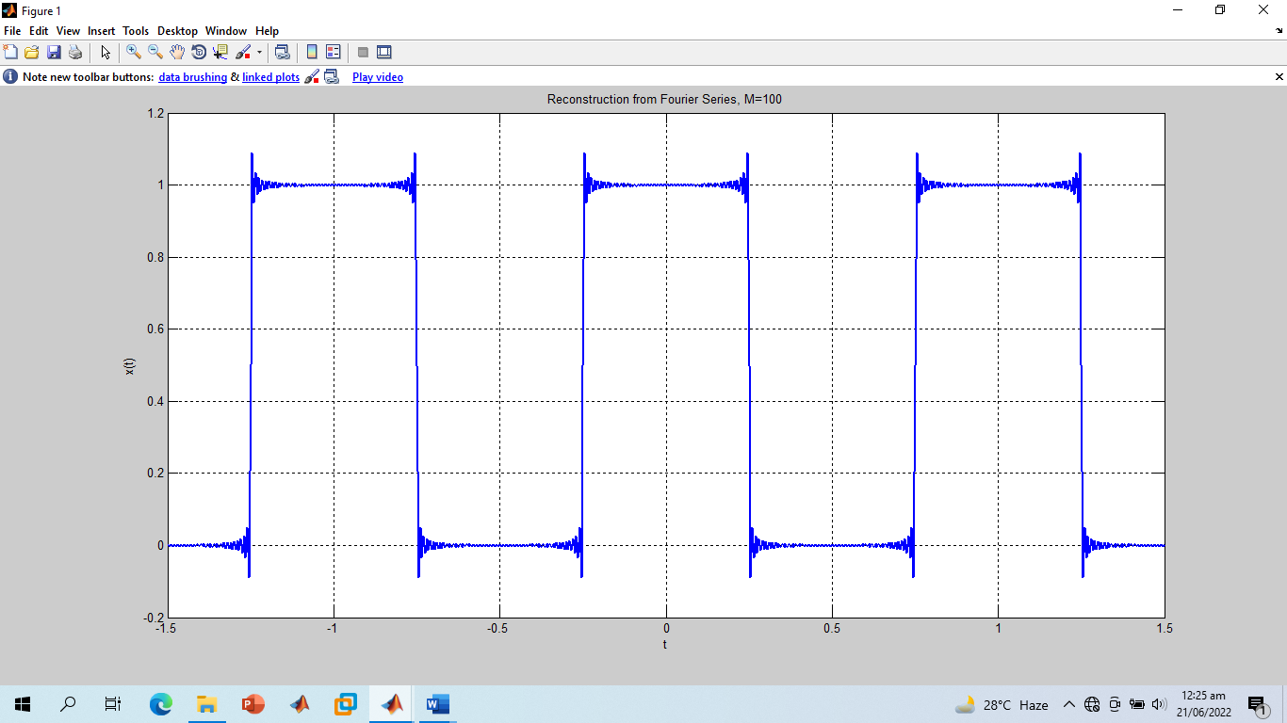

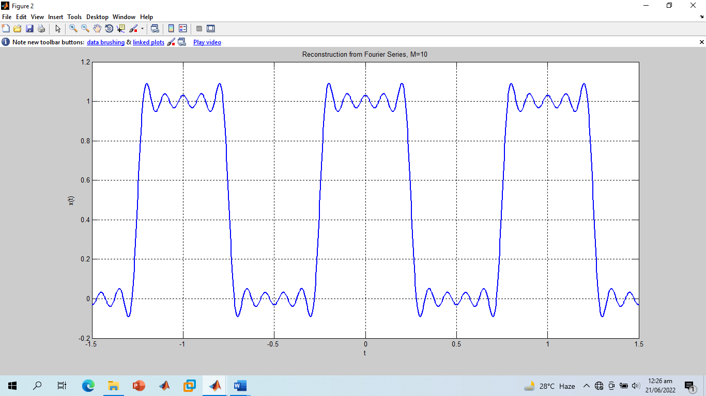

**-------------------------TASK 05--------------------------**

* Given the following FS coefficients:



Plot the coefficients & reconstructed signal. Take the terms for reconstructed signal to be M = 10, 20, & 60. What effect do you see when M is varied?

**Observation:**

* As the no of k increased from k=10 to k=60 so the no of signals will also increase which will added and give us smoothen resultant signal.

**Screenshot of Input:**

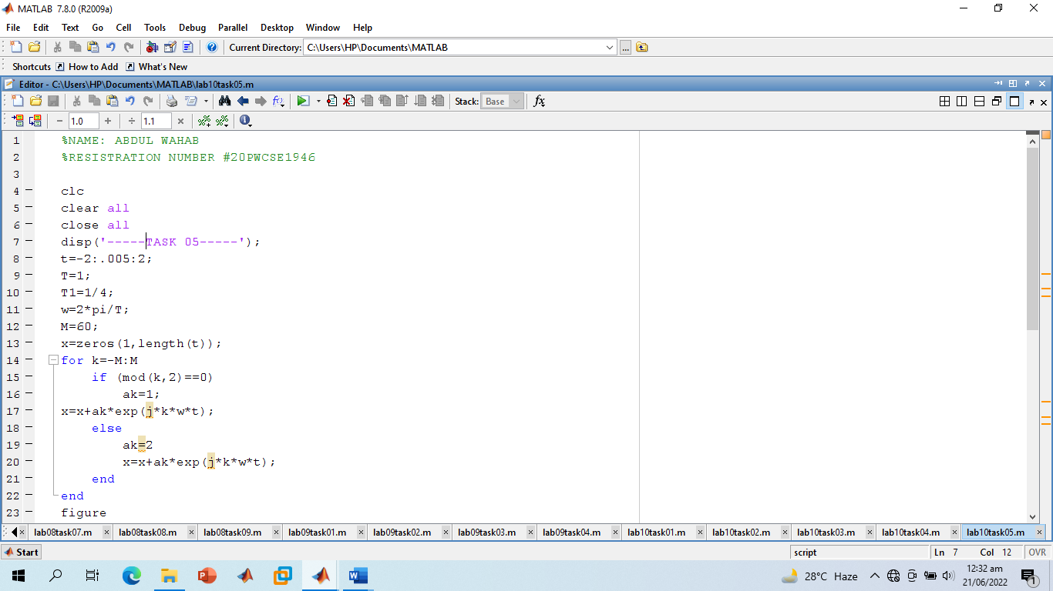

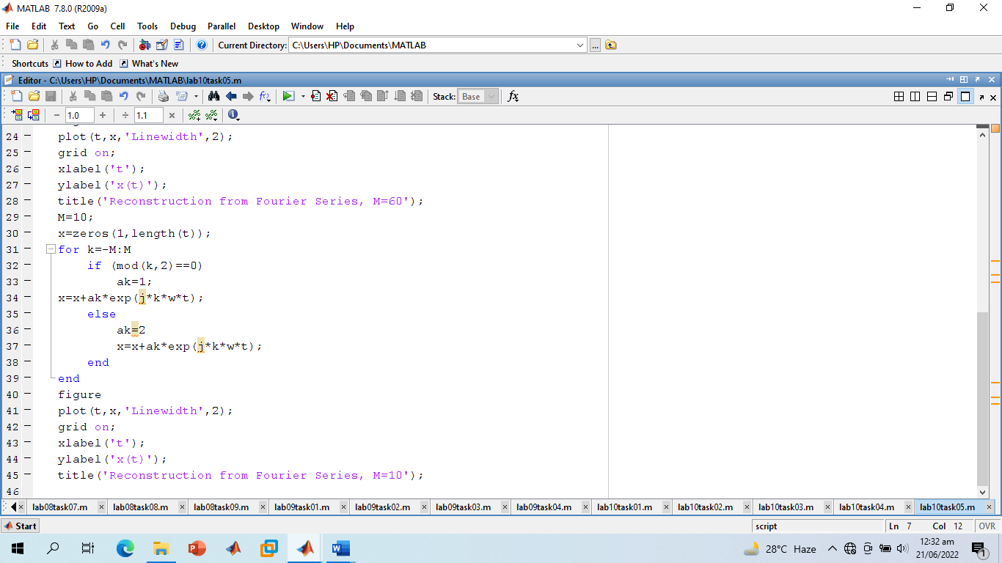

**Screenshot of Output:**

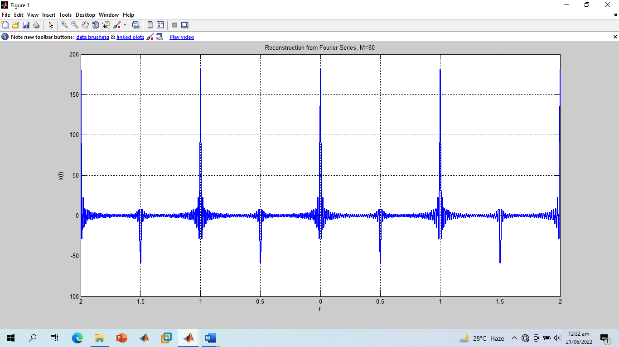

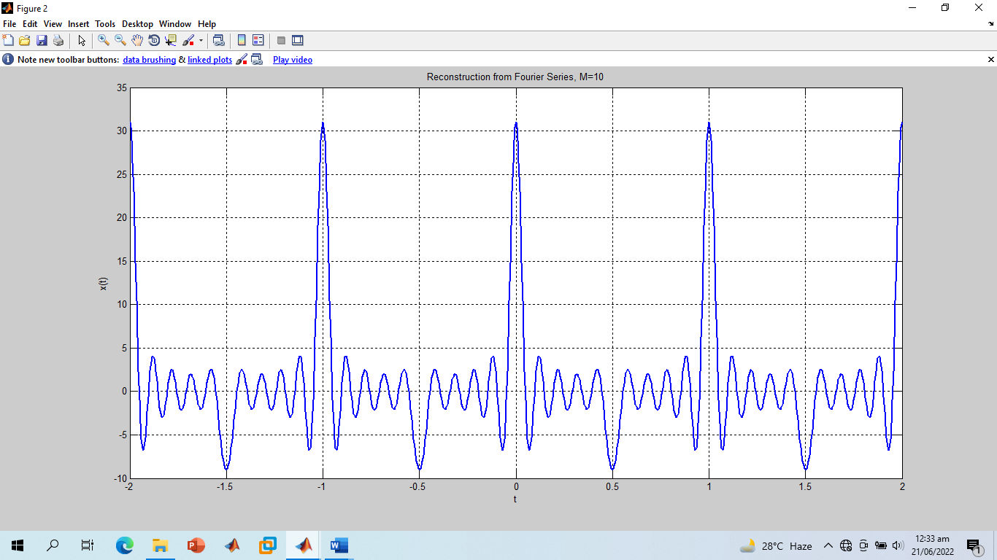

**-------------------------TASK 06--------------------------**

* Given the following FS coefficients:



Plot the coefficients & reconstructed signal. Take 10 terms (M=10) for reconstructed signal.

**Screenshot of Input:**

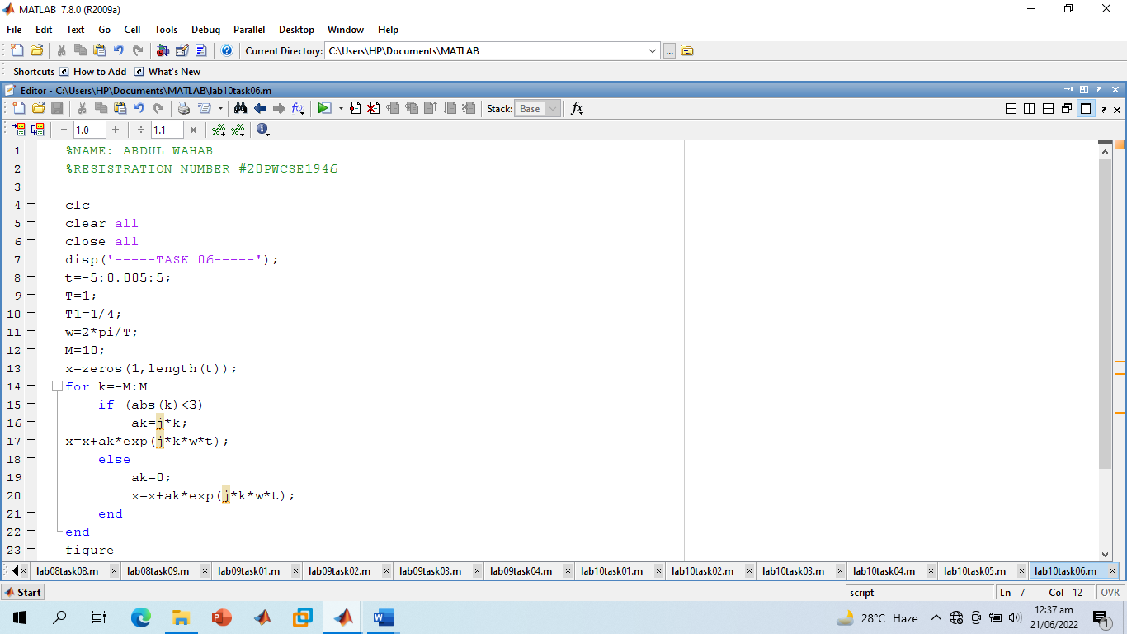

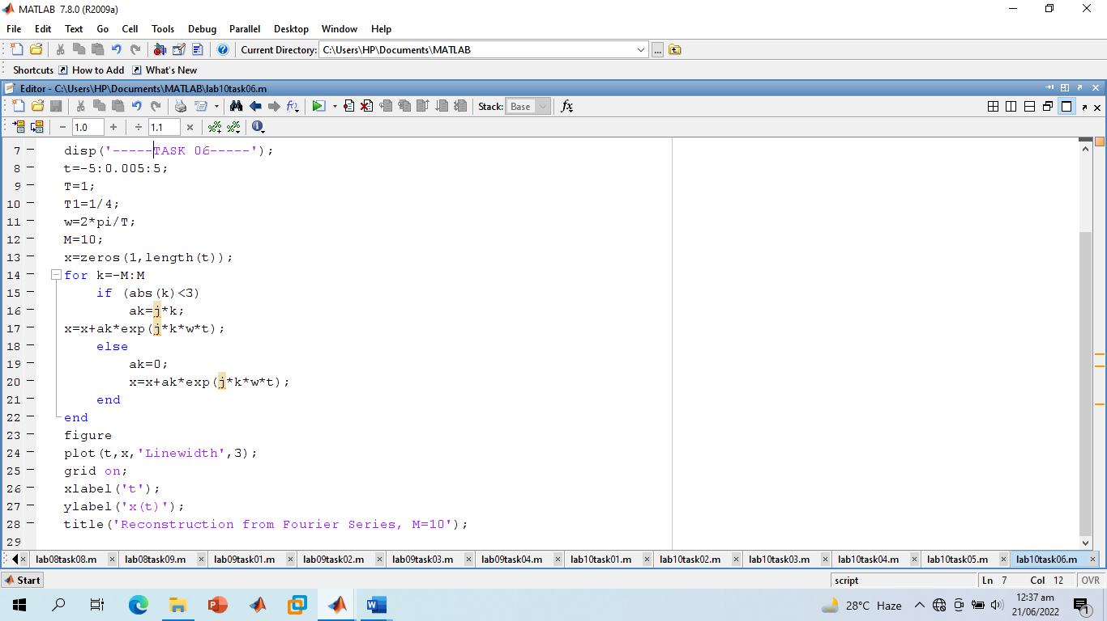

**Screenshot of Output:**

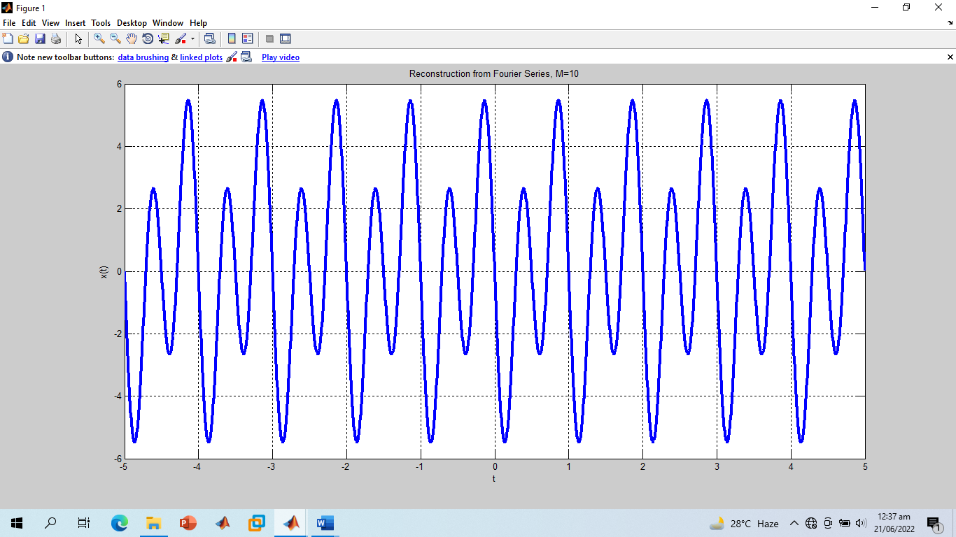

**------------------------------THE END------------------------------**